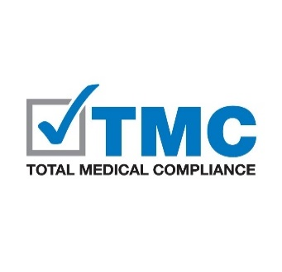

RANSOMWARE INCIDENT RESPONSE WORKSHEET
Use this form in addition to the Breach/Incident Investigation Report form in the Forms section of the Manual. Work with your IT/Security Officer to answer the questions below.

- Who discovered the attack?
- How did the office discover the attack?
- What was the date and time the attack was discovered?
- Which computer/device was the attack discovered on?
- Was the PHI restored/recovered? Yes No
If No, was the PHI stolen or removed from the network?
Yes No Under Investigation (update this answer as needed)
- Was the PHI encrypted before the attack? Yes No
*Risk Point: if the answer is “Yes” the risk of compromise under the HIPAA 4-Part Breach Risk Assessment might be lower.
*Risk Point: the risk of compromise under the HIPAA 4-Part Breach Risk Assessment may be lower depending on the data elements involved in the attack.
- Was the attack reported to the FBI? Yes No
If “Yes” list the name and contact information of the FBI contact:
- Is the identity of the attacker known? Yes No
If “Yes” list here:
- Was the requested ransom paid to the attacker? Yes No

RECOVERY DETAILS
- What systems/databases and machines were impacted by the attack? If unknown, return and update this answer as needed.
- Was a backup of the data available to be restored? Yes No
  - If “No” was the backup corrupted? Yes No
  - If “No” was there no backups retained to be restored? Yes No
  - If “No” was a partial backup used? If so, describe. Yes No
- If a partial backup was restored, what is the date of the last backup? (e.g. all but the most recent 2 months have been restored):
- Is there ongoing monitoring for the same or similar virus at least 30 days?
Yes No
If “No” describe ongoing detection efforts:
- Who has been notified of the attack and when:
  - U.S. Department of Health and Human Services’ Office of Civil Rights (OCR):
  - State Attorney General:
  - Patients:
  - Other:

Notes/Attachments:

